Proposal for

<Client name>

Blackboard Ally is a revolutionary product that focuses on making digital course content more accessible. Using inclusivity, sustainability and automation as its key pillars, Blackboard Ally helps you understand and tackle accessibility in a way that benefits all students.

Highlights of Blackboard Ally

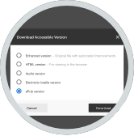 | Alternative Accessible Formats  Using advanced machine learning algorithms, Ally provides all students access to more accessible alternatives such as Semantic HTML, ePub, Audio and Electronic Braille.
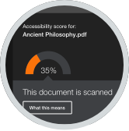 | Feedback and Guidance  Deliver in-context feedback and guidance to help instructors improve the accessibility of their content and build towards a sustainable change in behavior.
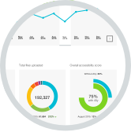 | Institutional Reporting  Gain deep understanding of your institution’s performance through the institution-wide course content accessibility report.

What’s Included in the solution?

LMS Integration
Raise awareness and visibility of accessibility by integrating directly into existing workflows. Ally will integrate with all courses in the Learning Management System and provides unlimited storage.

Technical Implementation
Basic technical configuration support to set up and configure the integration.

Report Orientation
Orientation for admins and accessibility staff to help understand and interpret the Ally reports.

SLA & Support
Service Level Agreement and Support are included.

Use of 3rd party services
Ally benefits from valued 3rd party services that are included in the solution (e.g., text-to-speech, OCR).

Pricing

For <Client Name> with the FTE range of <X-X>, running on <LMS>, the price is $<x> annually.
This cost proposal is valid until <Date>.

Optional End
User Training

If you are interested in help with rolling out this solution to instructors and students, we offer two additional options.

Remote Workshops
Two-hour synchronous session followed up by one hour of guided asynchronous hands-on practice. Pricing for each workshop is $2,000.

On-site Training
Customized agenda for each day focused on areas of interest around faculty feedback and alternative accessible formats. Pricing for each training day is $3,900 (2-day minimum).

