


A better Blackboard Learn
Blackboard Learn with the Ultra experience

Welcome to the community of institutions using the new version of Learn, Blackboard Learn with the Ultra experience – a more user-friendly and modern experience.
What does this mean for you? It means that upon logging into Blackboard Learn, you will see a new, fresh look and feel. Plus, you’ll be able to quickly access the latest, most critical information from across all of your courses and organizations. There is also a new, Ultra Course View that provides a simple, streamlined course experience for you and your students.

Highlights of Blackboard Learn with the Ultra experience include:

New and improved user experience with intuitive workflows. It offers a user experience that features a simple, modern, intuitive, and consistent
interface on any device.
Simplified navigation. Everything is just one click away. The new
navigation provides immediate access to the most critical information you need to be successful.
Use on any device. The responsive design ensures you have a great experience
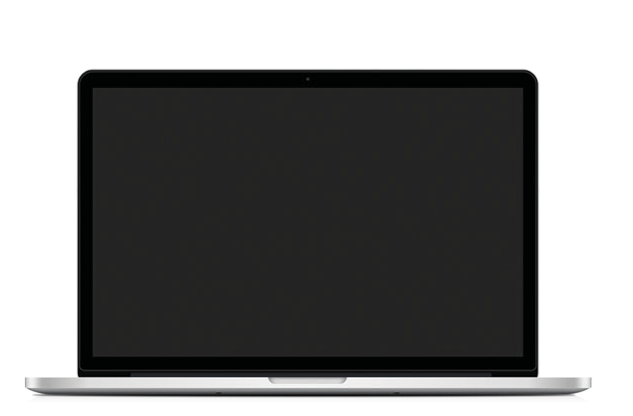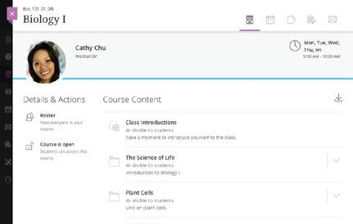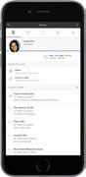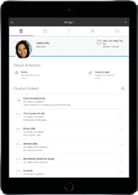accessing Blackboard Learn on any mobile device you use.

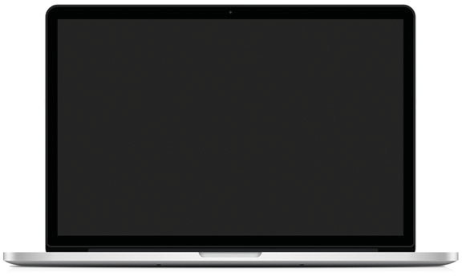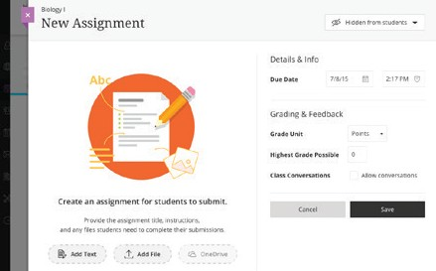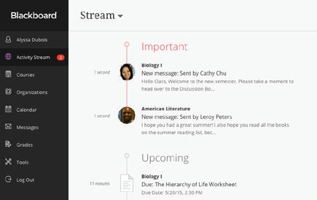

Optional, new Ultra Course View:
Content creation. Simply point to where you want to add content and a plus sign appears. Drag and drop for uploading works too. Point again to reorder, edit, or delete content.

Streamlined grading. On one page, you have immediate access to grading tasks for all courses. Quickly scan everything you need to grade – without navigating to each course.

Learning analytics.
Drive student success with embedded predictive analytics that alert both you and your students to take action.

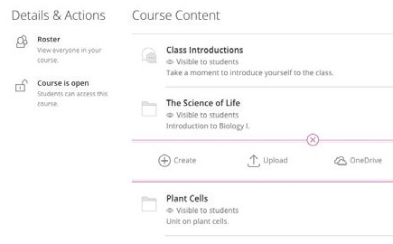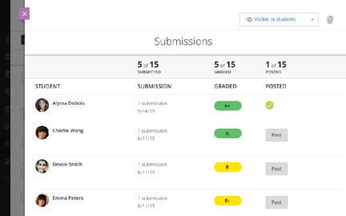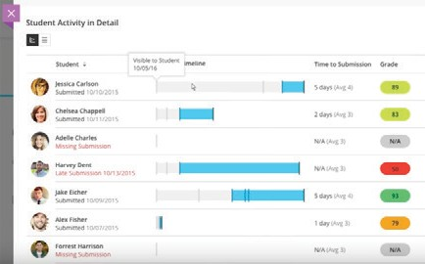

If you’re interested in learning more about the highlights listed above, check out the Blackboard Help site by clicking here.


Blackboard.com Copyright © 2017. Blackboard Inc. All rights reserved. Blackboard, the Blackboard logo are trademarks or registered trademarks of Blackboard Inc. or its subsidiaries in the United States and/or other countries.

